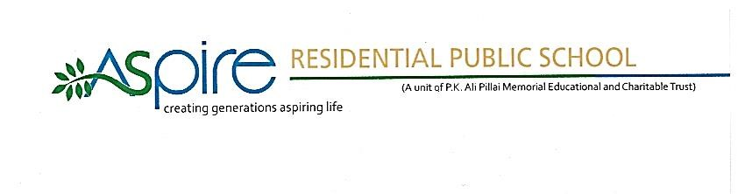

ART AND CRAFT – ANNUAL PLAN
(2021-2022)

MONTH | ACTIVITY | CLASS
JUNE | • Wall Decor  • Numerical Drawings  • Paper Mug  • Acrylic Paintings  • Paper Swing Part 1  • Acrylic Painting Part 1 | I-III  I-III  IV-VI  IV-VI  VII-VIII  VII-VIII

MONTH | ACTIVITY | CLASS
JULY | • Numerical Drawings  • Paper Bag  • Flower Making Part 1  • Paper Bag  • Acrylic Painting Part 2  • Paper Bag | I-III  I-III  IV-VI  IV-VI  VII-VII  VII-VII

MONTH | ACTIVITY | CLASS
AUGUST | • Tiger Paper Craft  • Independence Day Hand Fan  • Coconut Leaf Glass  • Pebble Art Tiger Paw  • Independence Day Badge  • Coconut Leaf Watch  • Tiger Book Mark  • Independence Day Flower  • Coconut Leaf Fish | I-III  I-III  I-III  IV-VI  IV-VI  IV-VI  VII-VIII  VII-VIII  VII-VIII

MONTH | ACTIVITY | CLASS
SEPTEMBER | • Paper Snake  • Teachers Day Card  • Red Panda Drawing  • Rhino pencil drawing  • Abstract Art  •Teachers Day Topper  • Red Panda Clay Modelling  • Flower Making Part 2  • Reuse of Cardboard  • Explosion Box  • Red Panda Drawing  • Rhino origami | I-III  I-III  I-III  I-III  IV-VI  IV-VI  IV-VI  IV-VI  IV-VI  VII-VIII  VII-VIII  VII-VIII

MONTH | ACTIVITY | CLASS
OCTOBER | • Painting Tree Part  • Gandhi Jayanthi painting  • Flying rocket  • Painting of tree  • Gandhi Jayanthi painting  • Simple model of rocket  • Paper swing  • Gandhi Jayanthi painting  • Newspaper rocket | I-III  I-III  I-III  IV-VI  IV-VI  IV-VI  VII-VIII  VI-VIII  VII-VIII

MONTH | ACTIVITY | CLASS
NOVEMBER | • Paper Diya  • Painting With Crayons  • Object Drawing  • Clay Modelling of Insects Part 1  • Clay Modelling of Insects Part 2  • Paper Lantern  • Painting With Crayons  • Boarder Drawing  • Clay Modelling of Vegetables Part 1  • Clay Modelling of Vegetables part 2  • Diwali Cards  • Paintings With Crayons  • Hawaii Beach Painting  • Clay Modelling of Animals part 1  • Clay Modelling of Animals part 2 | I-III  I-III  I-III  I-III  I-III  IV-VI  IV-VI  IV-VI  IV-VI  IV-VI  VII-VIII  VII-VIII  VII-VIII  VII-VIII  VII-VIII

MONTH | ACTIVITY | CLASS
DECEMBER | • Leaves And Bud Painting  • Christmas Tree Making  • New Year Wall Decor  • Abstract Art  • Christmas Tree Making  • New Year Wall Decor  • Tree in Different Background  • Snow Man Making  • New Year card | I-III  I-III  I-III  IV-VI  IV-VI  IV-VI  VII-VIII  VII-VIII  VII-VIII

MONTH | ACTIVITY | CLASS
JANUARY | • Cooling Glass Origami  • Pencil Drawing Part 1  • Republic Day Flag Making  • Rabbit Origami  • Kerchief Painting Part 1  • Kerchief Painting Part 2  • Republic Day Painting  • Flower origami  • Glass Painting Part 1  • Glass Painting Part 2  • Republic Day Painting  • Mini Bed Origami | I-III  I-III  I-III  I-III  IV-VI  IV-VI  IV-VI  IV-VI  VII-VIII  VII-VIII  VII-VIII  VII-VIII

MONTH | ACTIVITY | CLASS
FEBRUARY | • Simple Mandala Art  • Origami Doll  • Vegetable Painting  • Pencil Drawing Part 2  • Glass Mandala Art  • Glass Painting Part 1  • Glass Painting Part 2  • Pencil Drawing Mountains  • Peacock Mandala Art  • Kerchief Painting Part 1  • Kerchief Painting Part 2  • Pencil Drawing of sea | I-III  I-III  I-III  I-III  IV-VI  IV-VI  IV-VI  IV-VI  VII-VIII  VII-VIII  VII-VIII  VII-VIII

MONTH | ACTIVITY | CLASS
MARCH | • Drawing and Colouring Leaves Part 1  • News Paper Wall Decor  • Drawing and Colouring Leaves Part 2  • Dot Art  • News Paper Jar  • Cartoon Drawing  • Dot Art  • News Paper Cycle  • Cartoon Drawings | I-III  I-III  I-III  IV-VI  IV-VI  IV-VI  VII-VIII  VI-VIII  VI-VIII

